
Online Members Forum Nov. 7th, 2016 - 7 pm to 9 pm
Report to members since last meeting Sept. 12, 2016:
Ongoing events:

Pub nights – Go here (http://www.libertarian.on.ca/pub_nights) Toronto Pub nights have been very well attended for the last few months.
Woodstock?
Facebook/Twitter - Facebook Page & Group used as KPI Key Performance Indicators -
Our page: Likes on Feb 1/16 = 3770, Apr. 4/16 = 3880, June 6/16 = 4261, July 5/16 = 4312, Sept. 12/16 = 5011, Nov. 7/16 = 5535
Facebook Group: Sept. 11/16 = 1241, Nov. 7/16 = 1297 members
Actual paid party members have been steady and increasing midway between elections.

Annual General Meeting (AGM) on Saturday, October 22, 2016, and LPoC (Ont. Region) – Tim Moen attended and spoke
Some of the morning events may be seen here:
Facebook video: Allen Small and Jim McIntosh speaking
https://www.facebook.com/allen.libertarian/videos/vb.1216610834/10210481838541692/?type=2&theater#
Facebook video: Rob Brooks addressing the “plan”
https://www.facebook.com/allen.libertarian/videos/vb.1216610834/10210482302273285/?type=2&theater#

Afternoon voting at the AGM, the following people were elected:
Secretary - Ron White
Chair - Mark (Wojo) Wrzesniewski
Vice Chair - Marsha Haynes
Member at Large (x 2) - Matt Radford, Saxon Murray
Ethics Committee (x 2) - Neal Donnelly, Wendy Kadonoff

Also, in a separate election carried out online by members of the Caucus, the party Deputy Leader was elected = Deputy Leader - Rob Ferguson
Thanks to G.j. Hagenaars for supervising the entire online process.
All Executive Committee positions will come up for re-election at the next Convention in
Oct/Nov. 2017
The next Ontario General Election is slated for June 7, 2018.

Candidate Recruitment Road to 2018 - July 5/16 = 65, Sept. 11/16 = 92, Nov. 7/16 = 106 – estimated need ~162 for 122 ridings in 10 regions (coordinators)
*Tracking candidate dashboard:
https://libertarian.on.ca/utilities/nominations/nomination-dashboard.php

Be a candidate: https://libertarian.on.ca/civicrm/profile/create?gid=20&reset=1%2

How to take advantage of the free online candidate training?
Join our Wiki (http://wiki.libertarian.on.ca/ ) and be connected with how to access the free online training:
http://wiki.libertarian.on.ca/index.php?title =Candidate_Training

The course delivered by TJ Walker (New York):
http://courses.mediatrainingworldwide.com/courses/political-candidate-media-and-public-speaking-training

Coming Soon:

Set a goal to organize a party “Event” per month somewhere in the province.

A goal for the party: organize an Event per month - a money raiser? - movie night e.g.:
http://www.povertyinc.org
http://www.climatehustle.org

News about the two pending by-elections in Ontario.
Ottawa-Vanier still open Niagara Falls Glanbrook

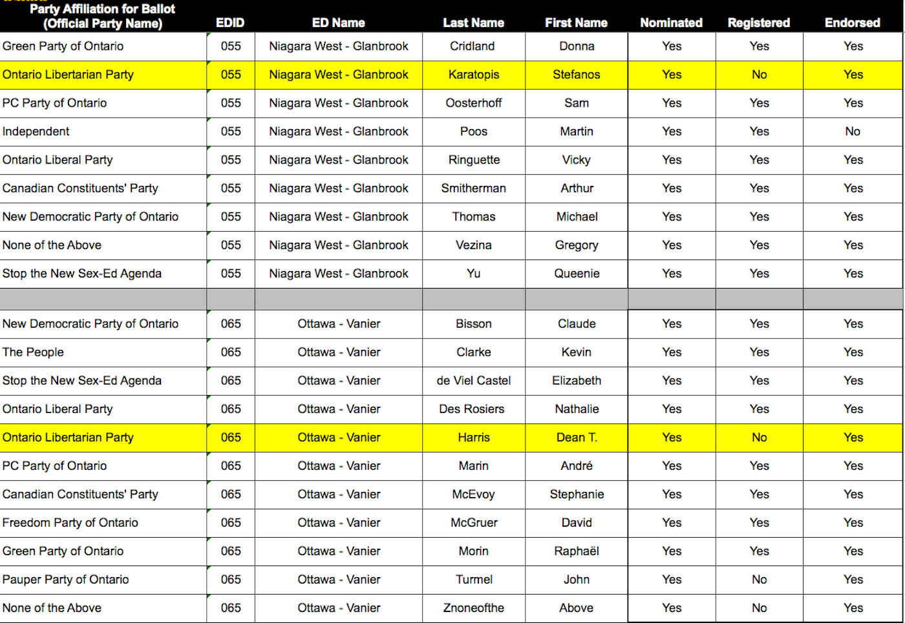

Discussion:
Platform: https://libertarian.on.ca/platform/platform2018

Now eight “planks” – card used in by-elections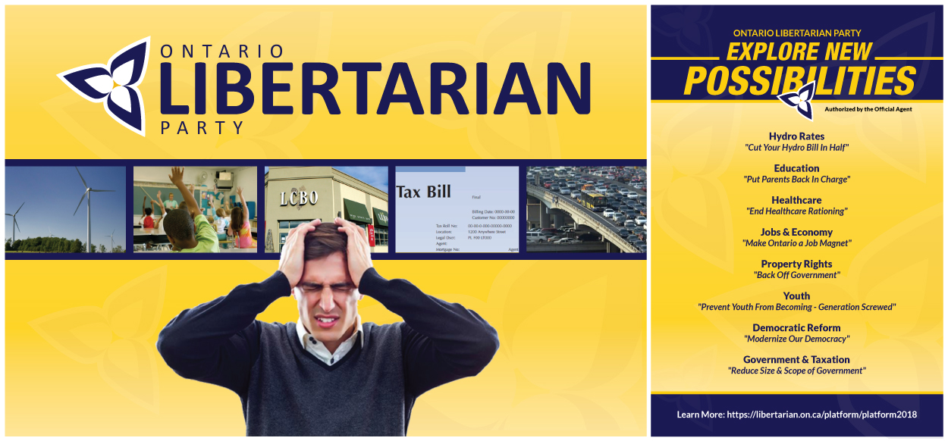

Healthcare: https://libertarian.on.ca/platform/platform2018/healthcare
Next meeting: Jan. 9, 2017

